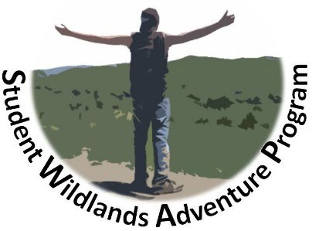
STUDENT WILDLANDS ADVENTURE PROGRAM
2023 SWAP EVENT
Northern New Mexico July 8-15, 2023

2023 Primary Sponsors:

Cleveland State Community College Greg Vital

What: Week-long chaperoned student excursion to Northern New Mexico
Where: Primary destinations are Carson and Santa Fe National Forests and Rio Grande Del Norte National Monument
When: July 8-15, 2023

Open To: College Students* pursuing a career in Wildlife or Natural Resource Management
* Must be 18 years of age or older by July 8, 2023.

The Student Wildlands Adventure Program (SWAP) is open for application to all college enrolled Natural Resource Management Students; however, preference will be given to students from underserved communities (students of minority descent or with financial hardship). Students must be 18 years of age or older and have an interest in pursuing a career in fisheries or wildlife management, forestry, range management, watershed management, hydrology, or other natural resources related field. Membership in the Wildlife Society or American Fisheries Society is preferred but not required. SWAP provides what may be a once-in-a-lifetime experience by allowing students from minority backgrounds or underserved communities to experience far away landscapes and cultures in a "hands-on" learning experience in natural resource management. The program is provided at little to no-cost to the participating students.

The 2023 SWAP event will take 12-15 students to the varied ecosystems of Northern New Mexico. The focus of the week-long adventure will be on wildlife, fisheries, and natural resource management in a western landscape.
Temperatures in the mountains of Northern New Mexico during the early summer should be mild (70-80 degrees F) but could see unusually warm or cold spells if a weather system moves in. July is the start of the monsoon season in the Southwest so afternoon thunderstorms may pop up suddenly. Some strenuous hiking will be involved. For more information, students should contact Robert Brewer at (865) 385-3670 (cell phone). Leave a message and calls will be returned promptly.

To apply, simply fill out the following application and submit BEFORE the deadline! It’s that easy!

All Applications Must Be Received by Feb. 15, 2023.

Selections will be made by March 1, 2023 and students will be notified by March 15, 2022. Only COMPLETE APPLICATIONS will be accepted. Please e-mail completed applications to: swapwildlife@gmail.com. Hand-written applications can be mailed to Robert Brewer at 5217 Horsestall Dr., Knoxville, TN 37918. For questions about this year’s SWAP program, contact Robert at the above e-mail or by phone at: (865) 385-3670.

2023 STUDENT WILDLANDS ADVENTURE PROGRAM - CHECKLIST
Make sure you have completed and enclosed the following materials:
- Application Form
- Essays
To be completed if selected:
- Student Emergency Medical Information Form
- Signed Student Conduct Agreement
- Signed Student/Parent Contract*
- Signed Picture Release Statement*
* Students must be 18 years of age or older by July 8, 2023. Selected students will be asked to travel to the nearest major airport and may be required to pay baggage fees.

ALL APPLICATIONS AND ESSAYS MUST BE RECEIVED BY Feb. 15, 2023.

PLEASE SEND COMPLETED APPLICATIONS WITH ESSAYS TO:

(Preferred)
E-MAIL: swapwildlife@gmail.com or
SWAP Student Trip 5217 Horsestall Drive
Knoxville, TN 37918
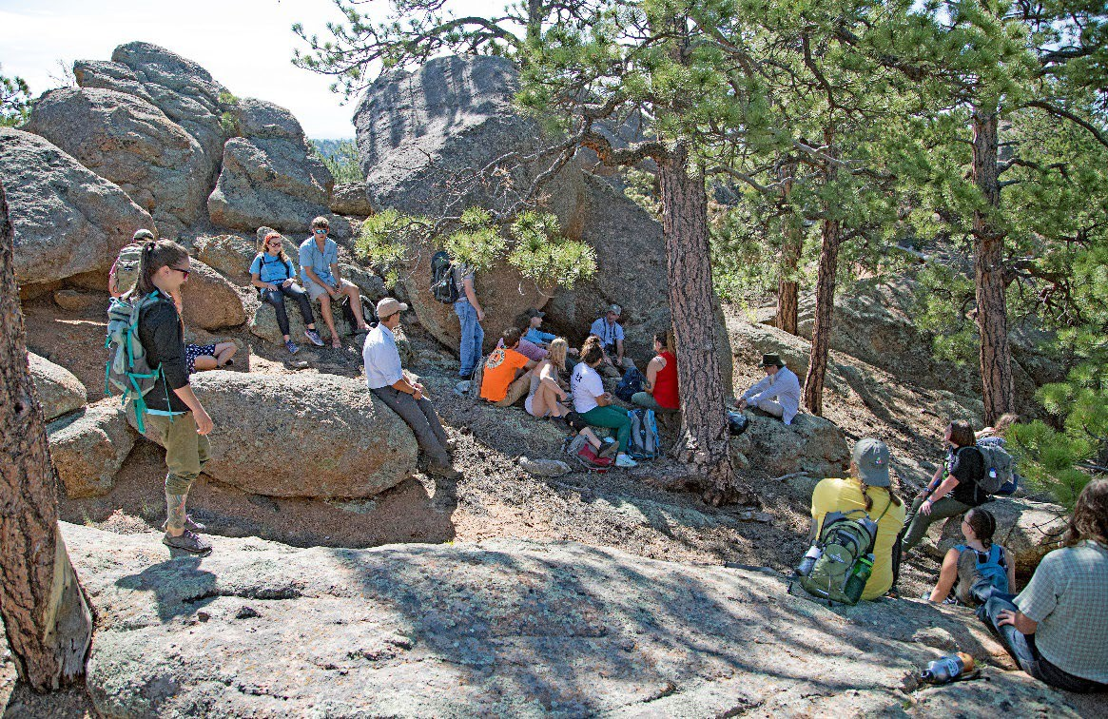
2019 SWAP trip to Northern New Mexico. Students visiting Aldo Leopold’s Cabin, Carson NF.

2023 Student Wildlands Adventure Program
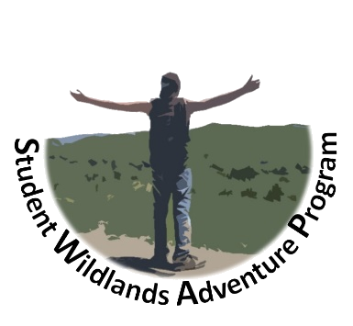
Application /Admission Form

Name:

Address:

City:
State:
Zip Code:

Phone: Date of Birth:

E-mail Address:

School: Grade (Fr/Soph/Jr/Sr):

Primary Course of Study

*** The following questions are optional but strongly encouraged. Answers will not rule out any applicant. They are used solely to determine need.

Are you of minority descent or come from an underserved rural community? (Yes/No)

Annual Family Income:
less than $50,000
$50,000 - $100,000
$100,000 - $150,000
over $150,000

Race:
American Indian or Native Alaskan Black or African American
Asian, Native Hawaiian, or Pacific Islander White

Ethnicity:
Hispanic, Latino, or Spanish Origin Not Hispanic, Latino, or Spanish Origin

If Native American, what tribe/pueblo/nation?

* * * MUST DO! * * *
Please answer the following questions. No more than one paragraph for each.

- How did you become interested in wildlife, fisheries, or natural resources management?

- Which National Parks in the U.S. have you visited and which one is your favorite?

- Why would you like to visit Northern New Mexico?

- What would be your dream job and why?

*Upon completion, save as "LastName_SWAP2023" and email to swapwildlife@gmail.com.

